Chapter 8 – Genetics Lesson 2 – Understanding Inheritance

What controls traits?

Mendel concluded that two factors control each trait.

One factor comes from the egg cell

One factor comes from the sperm cell.

Chromosomes

Inside each cell is a nucleus that has threadlike structures called chromosomes. Chromosomes contain genetic information that controls traits.

Each cell in an offspring contains chromosomes from both parents. These chromosomes exist in pairs—one chromosome from each parent.

Genes and Alleles

Each chromosome can have information about hundreds or thousands of traits. A gene is a section on a chromosome that has genetic information for one trait. (For example, a gene of a pea plant might have information about flower color).

An offspring inherits two genes (factors) for each trait, one from each parent.

The genes can be the same or different, such as purple or white for pea flower color. The different forms of a gene are called alleles. Pea plants can have two purple alleles, two white alleles, or one of each allele.

Genotype and Phenotype
Geneticists call how a trait appears, or is expressed, the trait’s phenotype. A person’s eye color (blue, brown, green, or other colors) is an example of phenotype.
Mendel concluded that two alleles control the expression or phenotype of each trait. The two alleles that control the phenotype of a trait are called the trait’s genotype. You cannot see an organism’s genotype. But you can make guesses about a genotype based on its phenotype.
For example, you have already learned that a pea plant with white flowers has two recessive alleles for that trait. These two alleles are its genotype. The white flower is its phenotype.

Symbols for Genotype
Scientists use symbols to represent the alleles in a genotype.
- Uppercase letters represent dominant alleles
- Lowercase letters represent recessive alleles.
The dominant allele, if present, is written first. The round pea seed can have either of these two genotypes—RR or Rr. Both genotypes have a round phenotype. Rr results in round seeds because the round allele (R) is dominant to the wrinkled allele (r).
The wrinkled pea can have only one genotype—rr. The wrinkled phenotype is possible only when two recessive alleles (rr) are present in the genotype.
The table below shows the possible genotypes for both round and wrinkled seed phenotypes.
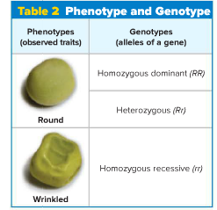
Homozygous and Heterozygous
When the two alleles of a gene are the same, its genotype is homozygous. Both RR and rr are homozygous genotypes. The RR genotype has two dominant alleles. The rr genotype has two recessive alleles.
If the two alleles of a gene are different, its genotype is heterozygous. Rr is a heterozygous genotype. It has one dominant and one recessive allele.
Modeling Inheritance
Plant breeders and animal breeders use two tools to help them predict how often traits will appear in offspring. These models, Punnett squares and pedigrees, can be used to predict and identify traits among genetically related individuals.
Punnett Squares
If the genotypes of the parents are known, then the different genotypes and phenotypes of the offspring can be predicted.
A Punnett square is a model used to predict possible genotypes and phenotypes of offspring.
Follow the steps shown below to learn how to make a Punnett square.
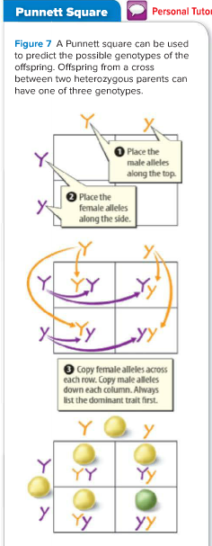

Analyzing a Punnett Square
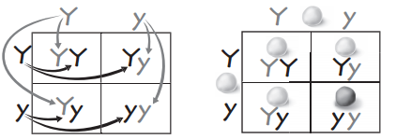
The figure shows a cross between two pea plants that are heterozygous for seed color—Yy and Yy.
- Yellow is the dominant allele—Y.
- Green is the recessive allele—y.
- The offspring can have one of three genotypes—YY, Yy, or yy.
- The ratio of genotypes is written as 1:2:1.
YY and Yy represent the same phenotype (yellow). yy represents the phenotype (green)
The offspring can have one of only two phenotypes—yellow or green.
The ratio of phenotypes is written 3:1. About 75 percent of the offspring of the cross between two heterozygous plants will produce yellow seeds. About 25 percent of the plants will produce green seeds.

Using Ratios to Predict
A 3:1 ratio means that an offspring of heterozygous parents has a 3:1 chance of having yellow seeds. (It does not mean that any group of four offspring will have three plants with yellow seeds and one with green seeds).

One offspring does not affect the phenotype of other offspring. But if you examine large numbers of offspring from a particular cross, as Mendel did, the overall ratio will be close to the ratio predicted by a Punnett square.

Pedigrees
Another model that can show inherited traits is a pedigree. A pedigree shows phenotypes of genetically related family members and it can also help determine genotypes.
In the pedigree shown below, three offspring have a trait—attached earlobes— that the parents do not have.
If these offspring received one allele for this trait from each parent but neither parent displays this trait, the offspring must have received two recessive alleles.
If either allele was dominant, the offspring would have the dominant phenotype—unattached earlobes.
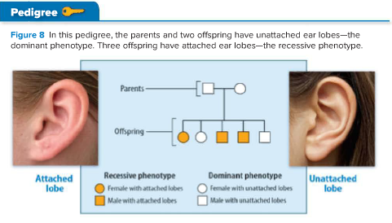

Complex Patterns of Inheritance
Mendel studied traits influenced by only one gene with two alleles. We know now that not all traits are inherited this way. Some traits have more complex inheritance patterns.
Types of Dominance
Recall that in pea plants, the presence of one dominant allele produces a dominant phenotype. However, not all allele pairs have a dominant-recessive interaction.
- Incomplete Dominance Sometimes traits appear to be blends of alleles. Alleles show incomplete dominance when the offspring’s phenotype is a blend of the parents’ phenotypes.
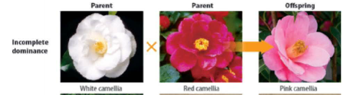
Example, a pink camellia flower results from incomplete dominance. A cross between a camellia plant with white flowers and a camellia plant with red flowers produces only camellia plants with pink flowers.

- Co-dominance When both alleles can be observed in a phenotype, this type of interaction is called co-dominance.
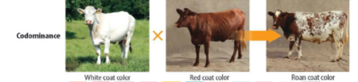

Example, if a cow inherits the allele for white coat color from one parent and the allele for red coat color from the other parent, the cow will have both red and white hairs.

Multiple Alleles
Unlike the genes in Mendel’s pea plants, some genes have more than two alleles, or multiple alleles.

Example - Human ABO blood type is an example of a trait that is determined by multiple alleles.

There are three alleles for the ABO blood type—I ^{A} , I ^{B} , and i.

The way the alleles combine results in one of four blood types—A, B, AB, or O.

The I ^{A} and I ^{B} alleles are codominant to each other, but they both are dominant to the i allele.
Even though there are multiple alleles, a person inherits only two of these alleles, one from each parent, as shown below.

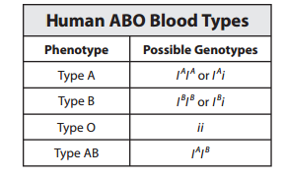

Polygenic Inheritance
Mendel concluded that only one gene determined each trait. We now know that more than one gene can affect a trait.
Polygenic inheritance occurs when multiple genes determine the phenotype of a trait.
Because several genes determine a trait, many alleles affect the phenotype even though each gene has only two alleles. Therefore, polygenic inheritance has many possible phenotypes. Eye color in humans is an example of polygenic inheritance. Polygenic inheritance also determines the human characteristics of height, weight, and skin color
Genes and the Environment
Genes are not the only factors that can affect phenotypes. An organism’s environment can also affect its phenotype.
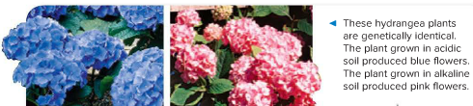
Example, the flower color of one type of hydrangea is determined by the soil in which the hydrangea plant grows. Acidic soil produces blue flowers. Basic, or alkaline, soil produces pink flowers.

For humans, healthful choices can also affect phenotype. Many genes affect a person’s chances of having heart disease. However, what a person eats and the amount of exercise he or she gets can influence whether heart disease will develop.

